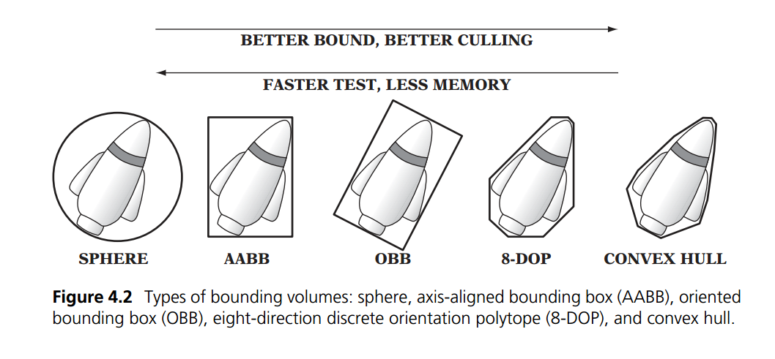Bounding Volumes

Axis Aligned Bounding Box (AABB)

rectangular six-sided box (in 3D, four-sided in 2D)

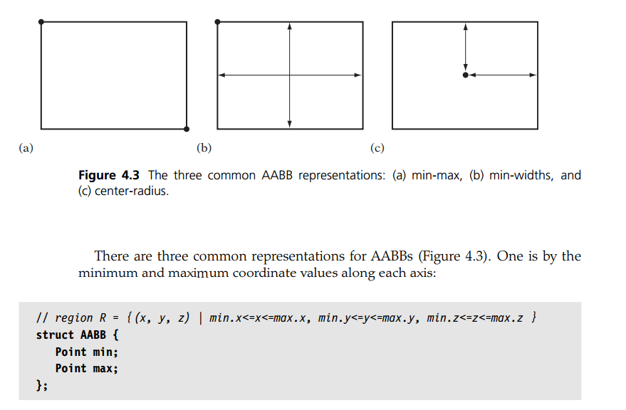

Sphere bounding volumes

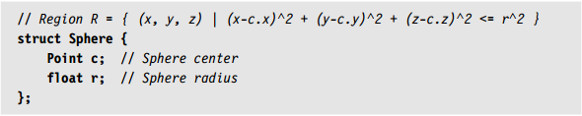

Computing an optimal bounding sphere is not as easy as computing an optimal axis-aligned bounding box.